L7. Regression I

The multiple linear regression model:
The multiple linear regression model following the OLS estimation method is the most basic of the plethora of regression models out there. It has the general form
$$y_{i}=β_{0}+β_{1}x_{i1}+β_{2}x_{i2}+…+β_{p}x_{ip}+ε_{i}$$
where :
- yi is a continuous dependent variable for the ith member of the sample .
- $β_{0}$ is the intercept. Sometimes it is also referred to as $α$ .
- $x_{ip}$ is a set of independent variables -i.e. key independent variables and controls.
- $β_{1}β_{2}…$ are regression coefficients.
- $ε_{i}$ is a residual or error term with zero mean that is uncorrelated with the independent
variables .
The most common form of linear regression is Ordinary Least Squares. It proceeds by minimizing the sum of the squares of the differences between the observed dependent variable and those predicted by the linear function. Essentially, what the OLS model does is to fit a line that reduces to the minimum the distance of the calculated line to the actual observed data.
Each regression coefficient represents the mean change in the dependent variable (y) when the corresponding independent variables (x) remain constant. The coefficients therefore represent the relationship of each independent variable, controlling for all other independent variables in the model, giving rise to the term ‘partial’ regression coefficients. In effect, this is the slope that would have occurred if all the other independent variables had been “controlled for”.
The residual is the difference between the observed value of the response and the value predicted by the independent variables. Significance tests for the regression coefficients can be derived by assuming that the error terms are independently normally distributed with zero mean and constant variance.
Ordinary least squares operates under a number of assumptions. Here is a quick summary:

- The regression model is linear in the coefficients and the error term
  - In the case that the relationship is not linear, OLS will underestimate the relationship between the independent variables and the dependent variable.
  - That being said, we can introduce higher order terms and interaction terms to represent non-linear relationships.
  - We can capture this in the exploratory analysis using the LOWESS curves and then, formal testing using F-tests.
- The error term has a population mean of zero:
  - In the case that the error term is does not have a mean value of zero, this means there are elements in the error term that are predictable. In other words, it means we are not specifying our model properly and our error term is correlated with our independent variables.
  - In general, if we include the intercept in our model, we should be fine with this assumption.
- All independent variables are uncorrelated with the error term.
  - Think of the error term as all that which we don’t include in our model. If the error term is correlated with our independent variables, it means that there may be some variable we are not including in our model that is important to explain our dependent variable. Hence, our model would be mis specified.
  - Another way to think of this is, in theory, the error term is supposed to be randomly distributed. If the error term is correlated with our independent variables, then it is not randomly distributed.
  - This is also highly related to the famous omitted variable bias.
- Observations of the error term are uncorrelated with each other.
  - One observation of the error term should predict another observation of the error term.
  - This usually happens if we fail to recognize a time series data structure or a multilevel data structure. Ultimately, this translates to the failure of not introducing a variable that captures that variation -e.g. country fixed-effects.
- The error term has a constant variance (no heteroscedasticity).
  - The variance of the errors should be consistent for all observations. In other words, the variance does not change for each observation or for a range of observations. This condition is known as homoscedasticity (same scatter). If the variance changes, we refer to that as heteroscedasticity (different scatter).
  - We should check this by plotting a graph of residuals vs fitted values. If we find a pattern in the scatter plot, then we can’t claim our residuals are homoscedastic -i.e. they are scattered equally.
- No independent variable is a perfect linear function of other explanatory variables.
  - If the Pearson’s correlation coefficient is +/- 1, then this means the two variables are perfectly correlated and make OLS unable to distinguish between two variables. Stata will either be unable to run the model or automatically drop the variable that is causing the perfect correlation.
  - A related problem that Stata will not capture automatically is when correlations are high. This is the classic problem of multicollinearity, which will allow the model to run, but will render biased and inconsistent estimates. In order to capture this issue, we can run variation inflation factor tests and/or tolerance tests.
- The error term is normally distributed (optional)
  - The way to test this is by plotting your residuals and testing whether the following a normal distribution. You can use the function qladder to test this.
  - This assumption is robust to violation and allows OLS to render precise estimates in the case that the error term is not normally distributed.

Now that we have reviewed OLS and multiple linear regression, let’s look at how to do it in Stata.

Regression:
The command regress fits a model of depvar on indepvars using OLS linear regression (the basic multiple regression model).
Syntax for OLS regression:
regress depvar [indepvars] [if] [in] [weight] [, options]
In our study of the Blau and Duncan status attainment model, we want to test the effects of parental occupation on respondents’ income and occupation, as mediated through education. The first step in a mediation analysis is to see whether our key independent variable is in fact associated with our mediator. Hence, we run a regression of parental occupation on years of education. Since parental occupation is an ordinal variable, we would want to introduce it in the model as a set of dichotomous variables and omitting the reference group. But first, how do we introduce the different types of variables into our model? This is the model we would like to specify:

DV: years of education. *Continuous
Key IV: father’s occupation at age 14 (3 category format) *Ordinal
Control: age *Continuous
Control: gender *Dichotomous

Hence, the code would be as follows:

reg eduyrs fath_occ14_3c agea male

However, there is a big problem with this code. Stata will recognize the type of variable you put in automatically if it is a dichotomous or a continuous variable. If the variable is ordinal or categorical, Stata will not recognize it and will assume it’s a continuous variable. We can do 2 things.

- We can dichotomize the different categories and introduce them as dummy variables. Always remember to omit one of the categories, we need a reference group. The fastest way to do this is by using the gen() option from the tabulate command.

Example:

tab fath_occ14_3c, gen(fathocc)

This will automatically create a dummy variable for each category. In between parenthesis you provide the stub and then Stata will create a variable named stub* for each category. Since we have three categories for father’s occupation, we will get three dummy variables named fathocc1 fathocc2 and fatchoc3.

If we were to follow this procedure, our regression command would be as follows:

Example:

Reg eduyrs fathocc2 fathocc3 agea male

- An easier way would be to use the i.prefix in Stata. This command tells Stata that the variable is a categorical or ordinal variable. Stata automatically selects the reference group based on the lowest value of the category. However, we can ask Stata to switch the reference categories by prefixing the variable with ib*. where * is the number of the category we wish to use as the reference.

Example:

reg eduyrs i.fath_occ14_3c agea male

reg eduyrs ib2.fath_occ14_3c agea male

Let’s look at the output:

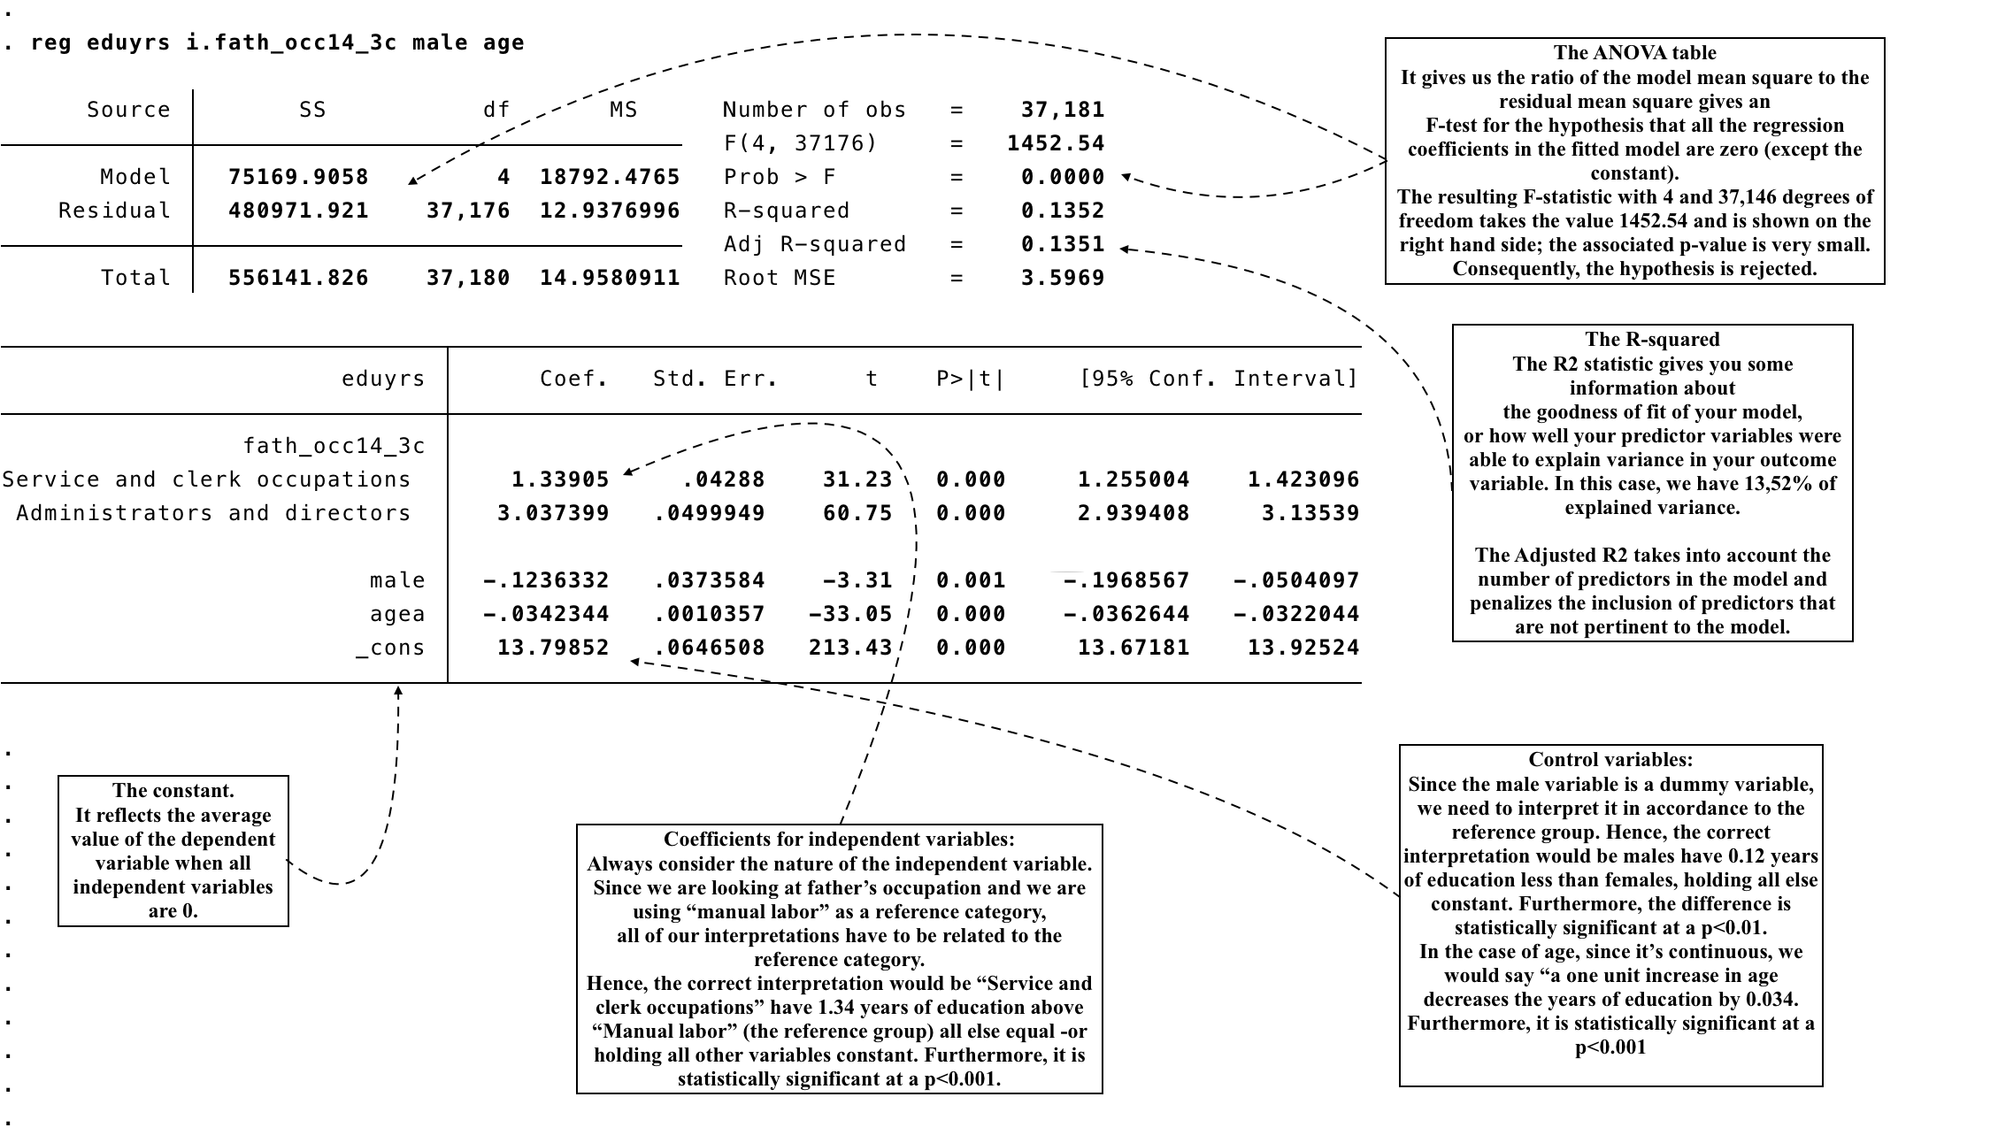

The predict command. Stata has a variety of post estimation commands. Predict is a particularly fun one. Predict calculates predictions, residuals, influence statistics, and the like after estimation. Exactly what predict can do is determined by the previous estimation command; command-specific options are documented with each estimation command. Regardless of command-specific options, the actions of predict share certain similarities across estimation commands:
1) predict newvar creates newvar containing "predicted values" -- numbers related to the E(y|x). For instance, after linear regression, predict newvar creates xb and, after probit, creates the probability F(xb).
2) predict newvar, xb creates newvar containing xb. This may be the same result as (1) (e.g., linear regression) or different (e.g., probit), but regardless, option xb is allowed.
3) predict newvar, stdp creates newvar containing the standard error of the linear prediction xb.
4) predict newvar, other_options may create newvar containing other useful quantities; see help for the particular estimation command to find out about other available options.
5) nooffset added to any of the above commands requests that the calculation ignore any offset or exposure variable specified by including the offset(varname_o) or exposure(varname_e) option when you fitted the model.
Syntax:
predict [type] newvar [if] [in] [, single_options]
Example:

predict eduyrs_hat
In this example we created a variable that contains the predicted values for years of education. The interesting thing about predict, is that you can treat it as any other variable and ask for descriptives. For instance, let’s say we want to know what are our predicted values of years of education for women.
Example:

sum eduyrs_hat if male == 0
Margins and marginsplot: Predicting Averages for Multiple Groups
Predict is fine if all we need to do is get an average of the dependent based on a couple of characteristics. But often, we have a bit more going on in our models. The margins command allows Stata to get the predicted means of the dependent for our variables. We can run margins right after the regression. In this example, we get the predicted average years of education for each group in the father’s occupation variable.
Example:
margins i.fath_occ14_3c

Stata has a great feature for plotting predicted values called marginsplot. After calling the margins command, you type in marginsplot and the resulting graph will show the linear prediction for the groups you have asked the margins for. This is often called a profile plot.
Multicollinearity check
It is at this point where you should be concerned over whether the regression assumptions are met. A lot of the assumptions can be approached from a conceptual point of view. For instance, if you are have a multilevel structure or an time series structure, a pooled OLS might be subject to autocorrelation and may violate the assumptions. However, there are others that need to be tested. The first one we need to look at is the assumptions related to correlation amongst your variables.
Keep in mind the correlation is not multicollinearity, a strong linear dependency might be a source of collinearity problems. We can investigate this further by calculating what are known as variance inflation factors (vif) and/or the tolerance for each of the independent variables. Vif is a post-estimation command that you should run after your regression command. You will get the following output:
On the left column, you get the Variance Inflation Factor. If values are near 10, then the VIF is problematic. On the right hand column you get Tolerance. If you find levels near 0, then you might have a multicollinearity problem. In the case that you do have a multicollinearity problem, you could consider either leaving one of the variables out of your model or combining the two variables that are correlated.
Examining the residuals:
The next step in the analysis should be an analysis of the residuals from the chosen model. In this example, the differences between the observed and fitted values of years of education.
Examining the residuals is a procedure vital for assessing model assumptions, identifying unusual features of the data including outliers, and suggesting possible simplifying transformations. Typically, graphs are the most helpful.
Syntax for residual-versus-predictor (rvf) plot:
regress yvar xvar
rvfplot

Example:

reg eduyrs i.fath_occ14_3c agea male

rfvplot

In this plot, the value of 0 on the y-axis (residuals) represents the cut-off point for how far away the fitted value is from the actual value. Ideally, you would want to see clustering around the 0 value, in a homogenous way that indicates no pattern. Below is a graph of our regression. It seems it is a good fit judging by the residual vs predictor plot. If we have a fanning pattern or a clustering in another area, then we need to think harder about our model because we are probably dealing with misspecification and/or violations of the assumptions.
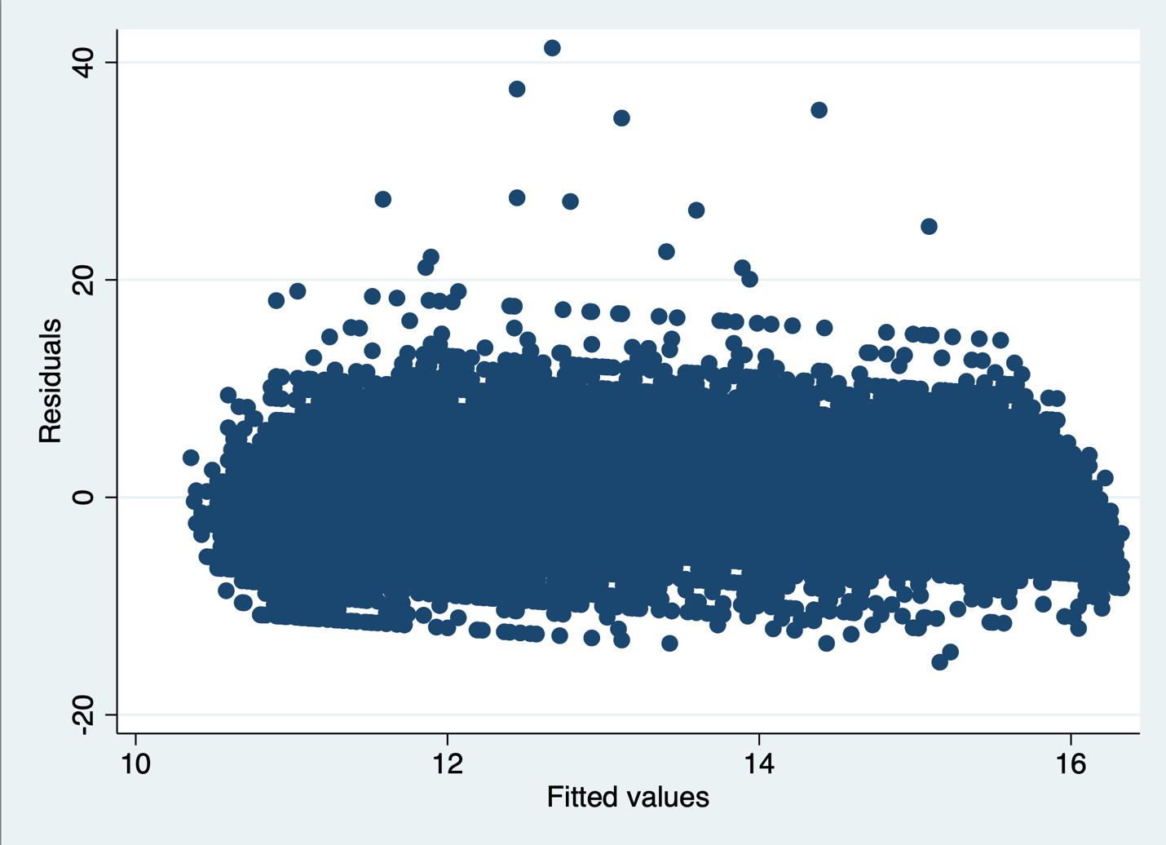

Breusch-Pagan / Cook-Weisberg test for heteroskedasticity
Another way to see whether the residuals are scattered equally is by formally testing it with the Breusch-Pagan / Cook-Weisberg test for heteroskedasticity. The null hypothesis represents constant variance. Hence, if the null hypothesis is rejected, we’d be looking at a heteroskedasticity problem.

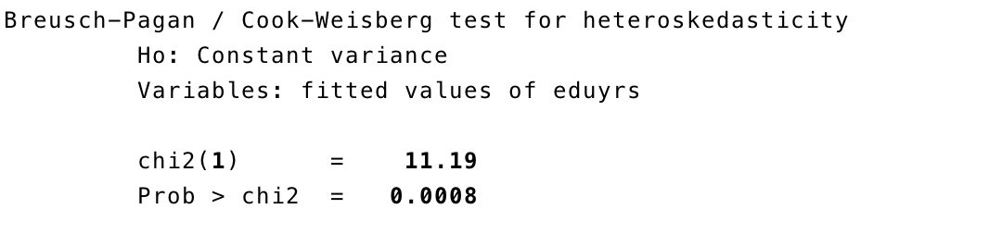
In this case, our model is not homoscedastic. We’ve rejected the null hypothesis of constant variance. This means we need to think harder about our model specification. The problem with this is that our standard errors are probably off.

There are many reasons why this may happen. You can think of two situations of heteroscedasticity:
- Pure heteroscedasticity: In this case, our model is correctly specified. However, because of the nature of our dataset -e.g. measurement error in the variables, sampling error, misrepresentation- we don’t have constant variance. This is common in cross-sectional data with really high number of populations it is trying to capture.

- Impure heteroscedasticity: In this case, our model is not properly specified. In other words, there is a mistake in how we are estimating y and the error is capturing it. There can be many errors in our specifications:
  - Variables are not properly transformed.
  - Outliers and influential cases.
  - Omitted variable bias.
  - Autocorrelation between observations. There may be an underlying structure that we are not accounting for in the data. There may be autocorrelation. If we can’t figure it out, a quick way of “getting around” this issue is using robust standard errors.
  - Your model needs to be weighted. Somehow, we need to find a way to weight the observations that are associated with higher variance of the error term.
  - Transform the dependent variable. I would save this resort for last and only if needed.

Example

reg eduyrs i.fath_occ14_3c male age , robust

Presenting output

Stata has a nice variety of ways to easily export the output to word. The first command we are going to learn is esttab. This command has many options that I encourage you to explore. This is a postestimation command that we need to run after we run a regression. However, the real strength of this command is that you can store your estimates and combine them in one table.

Example:

reg eduyrs fath_occ14_3c
est store model1

reg eduyrs fath_occ14_3c agea
est store model2

reg eduyrs fath_occ14_3c agea male
est store model3

esttab model1 model2 model3 using example.doc

Another incredibly useful command to present essentially any output you can think of is asdoc. It’s a user written command so you are going to have to use the help function or the findit function to install it. It is very easy to use. The only thing you have to do is put asdoc in front of any command you use. This will render a very neat and tidy table that barely needs any modification. The strength of this function is that it allows you to use it for any type of table you can think of. The down side of it is you cannot combine tables like with esttab.

Example:

asdoc sum eduyrs fath_occ14_3c agea male

This is the output you will get from the function above:

Descriptive Statistics
Variable | Obs | Mean | Std.Dev. | Min | Max
eduyrs | 43963 | 13.035 | 3.848 | 0 | 54
fath_occ1~3c | 37526 | .775 | .776 | 0 | 2
agea | 44232 | 49.143 | 18.613 | 15 | 100
male | 44378 | .474 | .499 | 0 | 1

