L9. Regression III

Nested regression and mediation

Mediation can be conceived as a channel or a mechanism. We are interested in looking at how a variable x affects a variable y, and how much of the effect of x occurs through a third variable z. Usually, the way to test this is by first looking at the effects of x on y and z separately in a regression.
First, we would run:

reg eduyrs fath_occ14 male agea

What we are interested in here is to see whether our key independent variable is statistically significant.

Then we would run:

reg hhincome i.fath_occ14 male agea

Here we are interested in seeing whether our key independent variable is also related to our dependent variable of interest.

Finally we would introduce:

reg hhincome eduyrs i.fath_occ14 male agea

Here we are interested in looking at our key independent variable’s coefficient. It’s dropped by half, meaning that about 50% of the effect of father’s occupation occurs through education. In other words, education is a significant mediator for social origins. However, father’s occupation is still statistically significant despite the fact that we introduced our mediator. What does this mean?

This is very tedious. We can streamline this process using nestreg:

nestreg: regress hhincome (fath_occ14 male agea) (eduyrs)

Nested regression consists in introducing different blocks of predictors. The big benefit from nested regression is that it shows exactly how much explained variation is achieved with every block inclusion. Furthermore, it provides a statistical test to contrast whether the change from one block to another is statistically significant. Here, we see introducing education increased explained variance by almost 6%. Furthermore, the F-test reveals the difference is statistically significant.

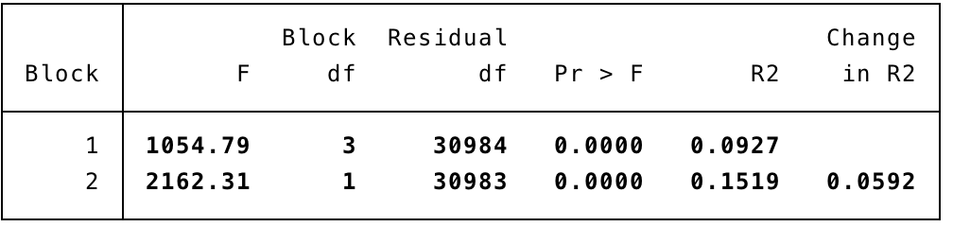

Non-linearity

Nestreg is ideal to test non-linear terms and factor variables. When it comes to non-linear terms, first we would inspect the bivariate relationship using lowess . If we suspect there might be a non-linear relationship, we generate a quadric term and test it using nestreg. Let’s look at age.

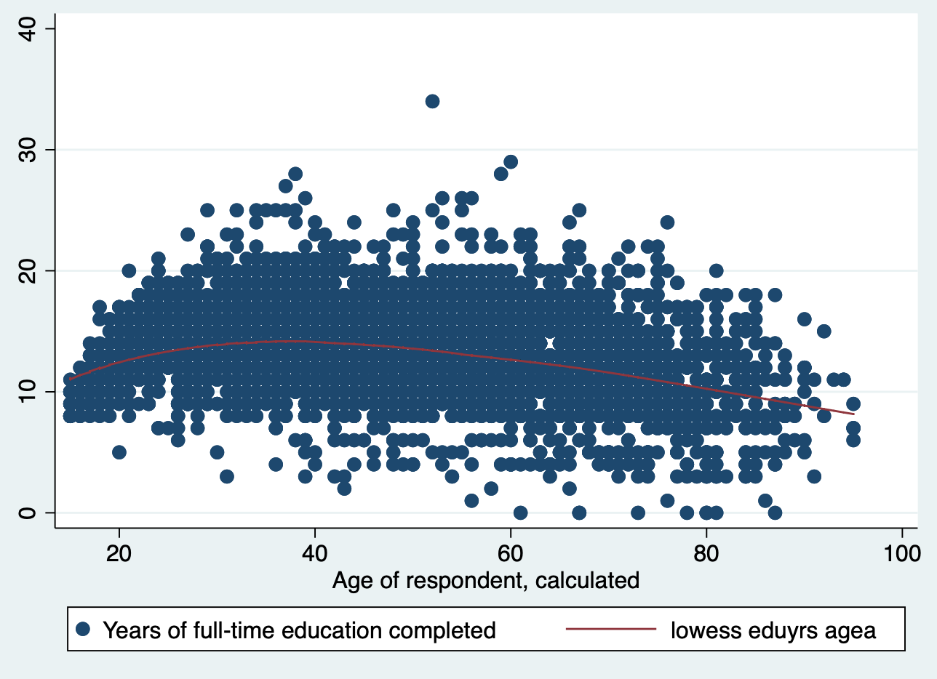

It seems like it could be curvilinear. Why would age have a negative curvilinear relationship with years of education? Cohort effects.
Since we could have a non-liner term. We will generate quadratic versions of age and test them using nestreg:

* generating a squared version of age
gen age_sq = agea^2

* generating a cubed version of age
gen age_cube = agea^3

* putting the nonlinear terms in the model

nestreg: regress eduyrs (agea) (age_sq) (age_cube)

The age_squared version’s coefficient is statistically significant. The way to interpret this is jointly with the regular age variable. At initial values of age, education increases, yet at higher values of age, education completion decreases. We are very interested in looking at the block information. This lets us know whether the inclusion of the squared term is actually relevant to the model. Is it? What do you think?

Discrete outcomes: Dichotomous outcomes.

In the case of a dichotomous outcome, we are interested in estimating the probability of whether an event occurs or not. When we have a dichotomous outcome we could estimate OLS. However, it entails a number of problems. This is what is known as the linear probability model.

- One of the assumptions of OLS is that the error is normally distributed. Since our dependent variable has only two potential values (1 or 0), our residual is necessarily going to be 1/0 minus the fitted value. Hence, it is clear that it cannot follow a normal distribution. This is not a big problem because normality is not an essential requirement for OLS to give unbiased estimates.
- Nonsensical predictions: LPM will render estimates that go beyond 1 and 0. For example, imagine we are estimating the probability that an individual has a heart disease. A LPM would give us estimates that go beyond 1 (occurrence) and 0 (absence of event).
- Functional form. The relationship between a dichotomous variable and the independent variables will have diminishing returns as the predicted probability approaches 0 or 1. The binary response model has an S-shaped relationship between the independent variables and the probability of an event. Hence, a linear estimation is going to fit the scatter poorly.
- Heteroscedasticity. Following up on the previous problem, the variance of the error is going to be different at each value of the independent. Hence, if we provide a linear estimation, our error variance is not going to be constant.

Because of these issues we use specific models dedicated to account for probabilities in discrete outcomes. Here, we are only going to look at logistic regression. In the future we will delve deeper into ordered outcomes, categorical outcomes, count outcomes, etc.

Logistic regression

One popular model in the social sciences to study dichotomous outcomes is the logistic regression. There are other very popular models like the probit model. However, here we will focus on logistic regression.

Syntax:

logit depvar [indepvars] [if] [in] [weight] [, options]

Let’s say we are interested in predicting the likelihood of every being unemployed. We want to see how one’s social origins might affect this. Logistic regression, as a default is expressed in logits. These units are not readily interpretable, so as a convention, researchers transform to odds ratios. This can easily be done by specifying the or option after the logit command.

Example:

logit unemployed i. fath_occ14_3c eduyrs male agea, or

Before we start interpreting our output…what is an odds ratio?
If we tab male by whether they’ve ever been unemployed, we get the table below. Let’s find out what are the odds -i.e. what is the probability- that a male has ever been unemployed.
Another way of asking this question is, out of all the males, what percentage has ever been unemployed? 6,039/14,898 = .40535642.
Now we do the same for females. 6.425/16.801 = .38241771
Now we have the odds of being unemployed for both groups.

Now we want to know what are the odds ratios of males being unemployed as compared to females. In other words, at what rate are males more likely to be unemployed than females:
.40535642 / .38241771 = 1.0599834

Always remember this calculation can only be applied to those categories coded 1.

Now let’s interpret the output.

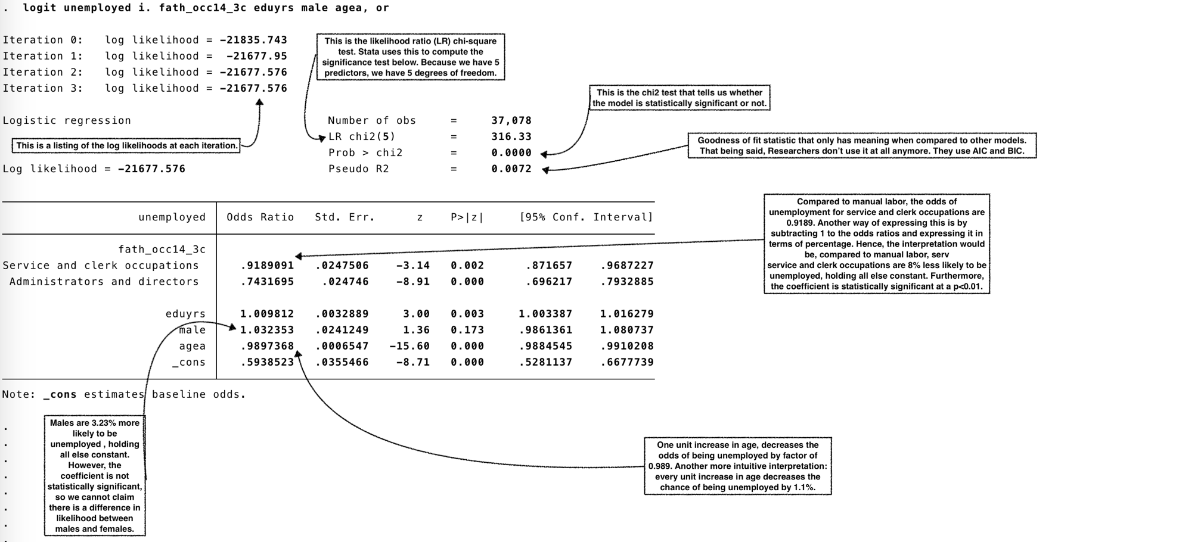

You can also call out the listcoef function. It will ease your day a lot:

