The Stata interface: What are all these windows in STATA?
The four main windows are the Review, Variables, Results, and Command windows. These are initially contained in the main Stata window. Each window has its name on its title bar. These four windows are typically in use the whole time Stata is open. You may also have the Properties window, which has details on the data set and, if highlighted, a specific variable. There are other more specialized windows, such as the Viewer, Data Editor, Data Browser, Do-file Editor, Graph, and Graph Editor windows – which will be discussed later.
The Command window
Commands are submitted to Stata from the Command window. The Command window supports basic text editing, copying and pasting, a command history, function-key mapping, and variable-name completion.

The Review window
The Review window shows the history of commands that have been entered, displaying successful commands in black, and unsuccessful commands, along with other error codes, in red.

To enter a command from the review window:
• Click once on a past command to copy it to the Command window, replacing the contents of the command window.
• Double-click on a past command to execute it.

Right clicking on the Review window displays a menu from which you can select
• Cut to remove the selected command(s) from the Review window and place them
on the Clipboard.
• Copy to copy the selected command(s) to the Clipboard.
• Delete to remove the selected command(s) to the Clipboard.
• Select All to select all the commands from the Review window, including those
before and after the commands currently displayed.
• Clear All to clear out all the commands from the Review window, including
those before and after the commands currently displayed.
• Do Selected to submit all the selected commands and add them to the bottom of
the command history. Stata will attempt to run all the selected commands, even
those containing errors, and will not stop even if a command causes error.
• Send to Do-file Editor to place all the selected commands into a new Do-file
Editor window.
• Save All... to bring up a Save Review Contents dialog, allowing you to save all
the commands in the Review window, including those before and after the
commands currently displayed, in a do-file.
• Save Selected... to bring up a Save Review Contents dialog, allowing you to save
the selected commands in the Review window in a do-file.

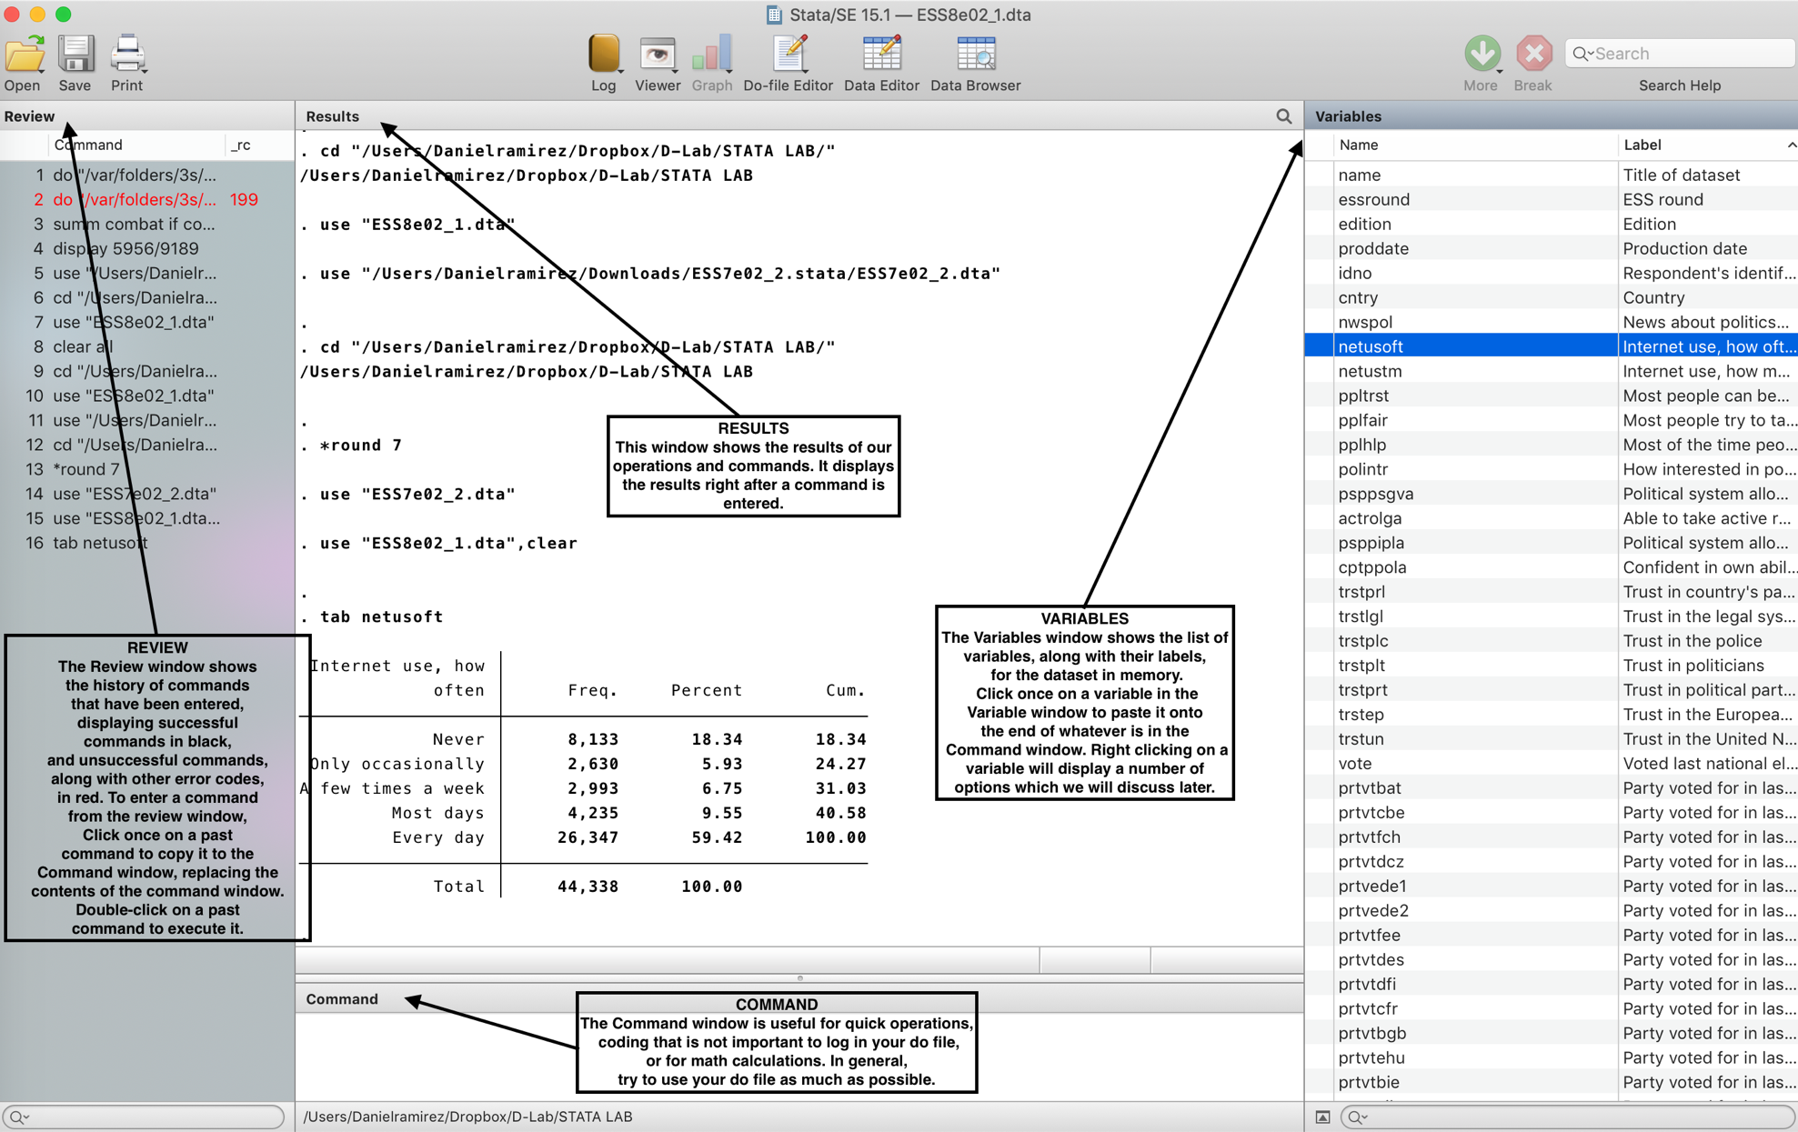

The Variables window
The Variables window shows the list of variables, along with their labels, for the dataset in memory. Click once on a variable in the Variable window to paste it onto the end of whatever is in the Command window. Right clicking on the variable will display a menu that allows to keep and drop the variable. For now, try to stick to the do file for this, at least until you really understand what these functions do.

The Properties window
This window is below the Variables window and tends to be hidden. You can reveal it by toggling the icon ( ) next to the search bar. This window gives us important information about the selected variable. It also gives us important information about the dataset we are using.

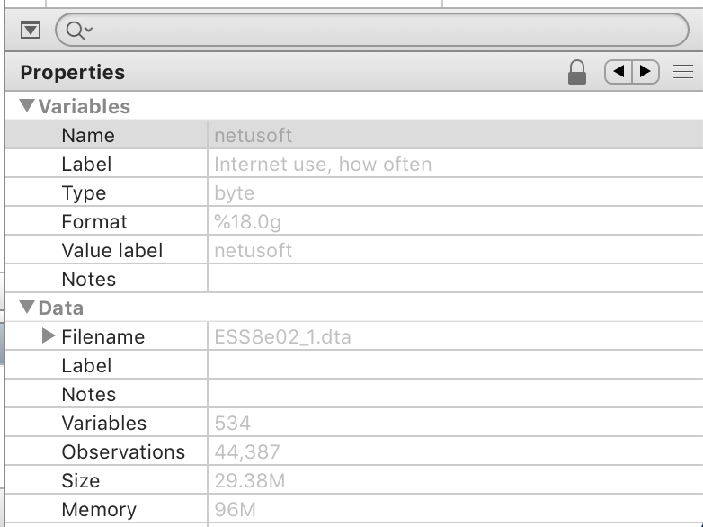

The tool bar

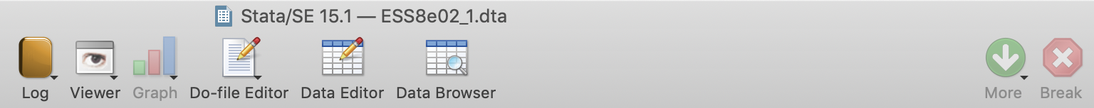
The toolbar contains buttons that provide quick access to Stata’s more commonly used features. If you forget what a button does, hold the mouse pointer over a button for a moment and a tooltip will appear with a description of that button. Buttons that contain both an icon and an arrow display a menu if you click the arrow.

- Open: Open a Stata dataset. Click the button to open a dataset with the Open dialog. Hold down the button to select a dataset from a menu of recently opened datasets.
- Save: Save the Stata dataset currently in memory to disk.
- Print: Print Results window. Click on the arrow to select a window to print.
- Log: Begin a new log or close, suspend, or resume the current log.
- Viewer: Open the Viewer, or bring a Viewer to the front of all other windows.
- Graph: Bring a Graph window to the front of all other windows.
- Do-file Editor: Open the Do-file Editor, or bring a Do-file Editor to the front of
- all other windows.
- Data Editor: Open the Data Editor, or bring the Data Editor to the front of the
- other Stata windows.
- Data Browser: Open the Data Browser, or bring the Data Browser to the front of
- other Stata windows.
- Go: Clear --more-- condition: Tell Stata to continue when it has paused in the
- middle of a long output.
- Break: Stop the current task in Stata.

